**Project Report**Cosmetic Insights : Navigating Cosmetics Trends and Consumer Insights with Tableau

**Team Members**

**Team ID:** **LTVIP2025TMID49157**

|  |  |
| --- | --- |
| **Team Leader** | Javvadi Venkata Karthik |
| **Member 1** | Geddada Uday Kiran |
| **Member 2** | Gayathri |
| **Member 3** | Gonaboina Bhanu Akash |

**1. INTRODUCTION**

**1.1 Project Overview**

The Cosmetic Insights project is an interactive data visualization solution designed to help cosmetic companies understand consumer preferences, analyze product trends, and make data-driven decisions. Using Tableau, the project transforms raw cosmetic product data — such as brands, prices, rankings, labels, and suitability for different skin types — into clear and actionable insights through dashboards and stories.

**1.2 Purpose**

The main purpose of this project is to empower cosmetic brands and stakeholders with visual, data-driven insights that reveal patterns in product popularity, price comparisons, ranking trends, and skin suitability. This helps businesses make better marketing strategies, improve product development, and stay ahead in a competitive market by understanding their customers’ needs in depth.

**2. IDEATION PHASE**

**2.1 Problem Statement**

**Customer Problem Statement :**

**I am...**  
A cosmetics user who deeply cares about my skin health, appearance, and finding the right products that suit my personal needs — whether it's related to skin type (oily, dry, sensitive), lifestyle, or ethical values (like cruelty-free or sustainable products).

**I'm trying to...**  
Discover and choose cosmetic products that are genuinely suited for my specific skin concerns, preferences, and budget, while staying updated on trends and making informed decisions.

**But...**  
I often face confusion and overwhelm due to the abundance of product choices, inconsistent or unclear labeling, and a lack of personalized recommendations that reflect my unique needs.

**Because...**  
Many brands and retailers present generic information, prioritize trends over transparency, and fail to offer user-friendly insights based on real consumer experiences or needs.

**Which makes me...**  
Feel frustrated, uncertain, and hesitant to try new products — leading to poor purchase experiences, wasted money, and dissatisfaction with my cosmetic journey.

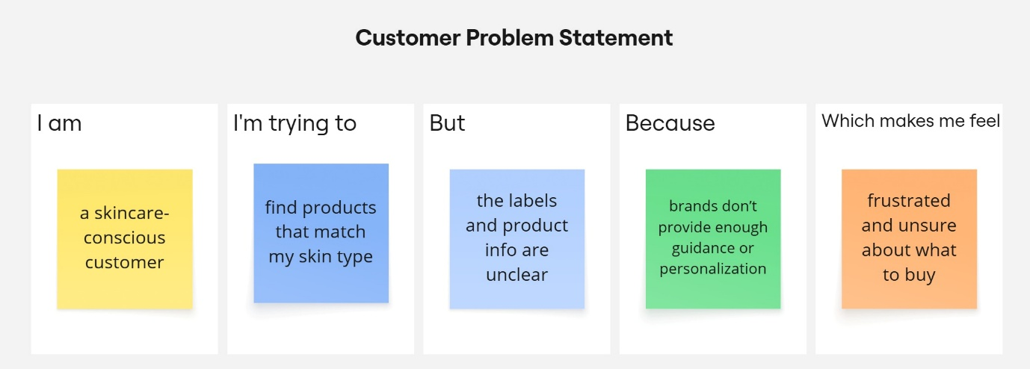

|  |  |  |  |  |  |
| --- | --- | --- | --- | --- | --- |
| **Problem Statement (PS)** | **I am (Customer)** | **I’m trying to** | **But** | **Because** | **Which makes me feel** |
| PS-1 | a customer with dry skin | find hydrating products that prevent flakiness | most products don’t last or worsen dryness | they lack proper moisturizing ingredients | disappointed and reluctant to try new items |
| PS-2 | a customer with sensitive skin | find cosmetics that don’t irritate my skin | many products cause redness or itching | brands don’t clearly list potential irritants | worried and unsafe using new products |

**2.2 Empathy Map Canvas**

**WHO are we empathizing with?**

**Primary Users:**

* Cosmetic brand managers
* Marketing analysts
* Product developers in the beauty industry
* Retailers selling cosmetics
* Skincare and beauty influencers
* Consumers curious about trends

**Key Stakeholders:**

* Data analysts using Tableau
* Business decision-makers
* Sales teams
* Marketing teams

**What do they NEED TO DO?**

* Understand emerging cosmetic trends quickly.
* Visualize complex consumer data in an easy, interactive way.
* Identify top-performing brands and products.
* Analyze consumer preferences (e.g., suitability for skin types).
* Track how labels and rankings affect buying decisions.
* Make data-driven product development and marketing strategies.

**What do they SEE?**

* Vast amounts of scattered cosmetic sales and feedback data.
* Fragmented or outdated reports.
* Competitors leveraging data visualization tools.
* New trends constantly changing (K-beauty, clean beauty, vegan, etc.).
* Shifts in consumer behavior post-pandemic.

**What do they SAY?**

* “We need clear dashboards to track market trends.”
* “It’s hard to make sense of raw data.”
* “We want to know what consumers really care about.”
* “We need to justify decisions with solid insights.”
* “We’d like to see visual stories, not just spreadsheets.”

**What do they DO?**

* Collect and store large datasets.
* Create basic charts and reports in Excel or older tools.
* Manually prepare presentations for stakeholders.
* Spend a lot of time cleaning and merging data.
* Rely on intuition when insights are unclear.

**What do they HEAR?**

* From leadership: “Bring innovative, data-backed recommendations.”
* From industry: “Visualization is key to competitive advantage.”
* From peers: “Better dashboards save us time.”
* From consumers: “We want transparency and personalization.”

**PAINS**

* Time-consuming data cleaning and reporting.
* Lack of user-friendly, interactive visuals.
* Difficulty understanding consumer segmentation.
* Missed opportunities due to delayed insights.
* Inability to clearly present data to non-technical stakeholders.

**GAINS**

* Easy-to-use Tableau dashboards to explore trends interactively.
* Faster, clearer decision-making.
* Better targeting of marketing campaigns.
* More innovative, consumer-driven product lines.
* Increased competitiveness in the cosmetic market.

**Solution Statement**

**“Cosmetic Insights” empowers cosmetic brands and analysts to explore, visualize, and understand cosmetic trends and consumer preferences using Tableau — turning scattered data into actionable insights for better products and smarter marketing.”**

**Example:**

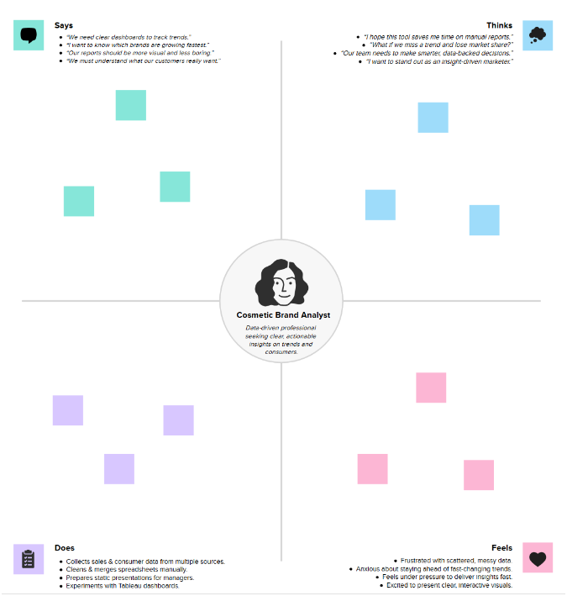

**2.3 Brainstorming**

**Brainstorm & Idea Prioritization:**

During the brainstorming phase of the Cosmetic Insights project, I explored various ideas to help users make better decisions when choosing skincare products. I focused on key areas like skin type suitability, brand-wise price comparison, and product ranking. I also considered using visual tools like word clouds to display common ingredients and bar charts to show product distribution by category. The goal was to build an interactive and insightful dashboard using Tableau. These ideas were chosen to solve real user problems and provide meaningful cosmetic recommendations through data

**Step-1: Team Gathering, Collaboration and Select the Problem Statement**

In the first step, our team was formed by gathering individuals with diverse skills and shared interest in data analytics. We collaborated to understand each member's strengths, such as data visualization, research, and communication. After a group discussion and brainstorming session, we shortlisted several potential issues in the cosmetics industry

problem statement: **“Understanding consumer insights and trends related to sensitive skin products”**. This topic was chosen based on current market demand and its relevance to real-world cosmetic usage patterns.

**Team Leader :** Javvadi Venkata Karthik

**Team member :** Geddada Uday Kiran

**Team member :** Gonaboina Bhanu Akash

**Team member :** Gayathri

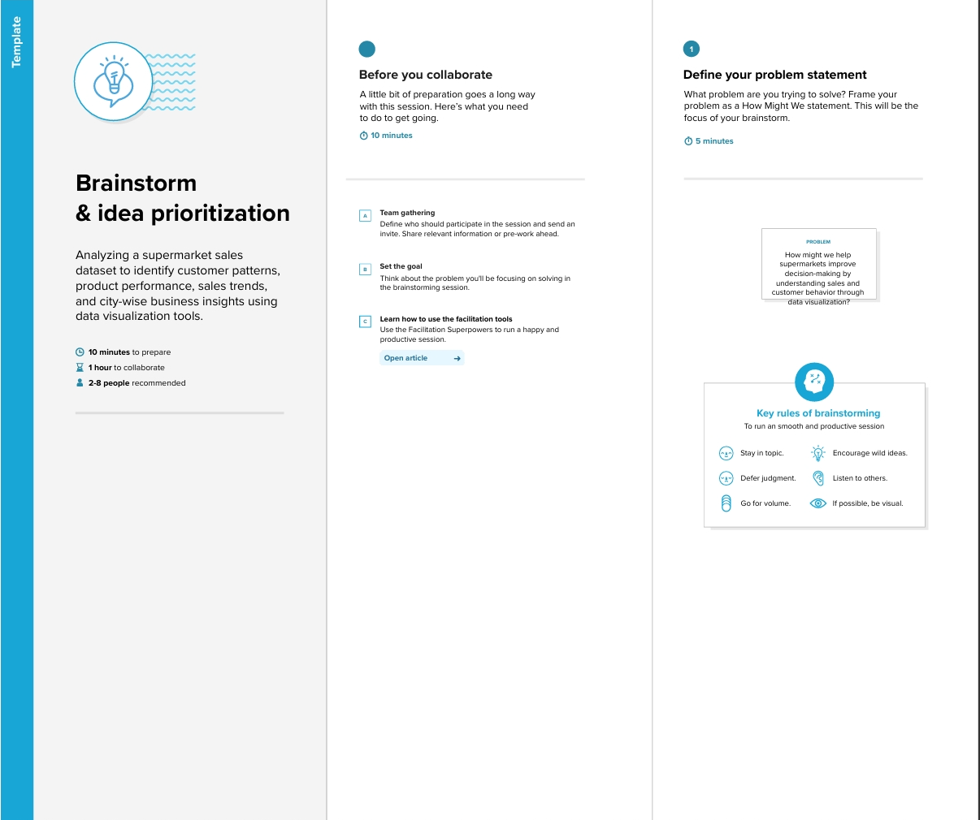

**Step-2: Brainstorm, Idea Listing and Grouping**

In this step, we listed multiple ideas related to analyzing cosmetics data, such as price comparison, skin suitability, and product ranking. These ideas were then grouped into categories like user needs, product features, and brand performance. This helped us focus on the most valuable insights for building the dashboard.

Then, we grouped similar ideas to identify key features for the dashboard like skin type filters, price analysis, and top brand insights.

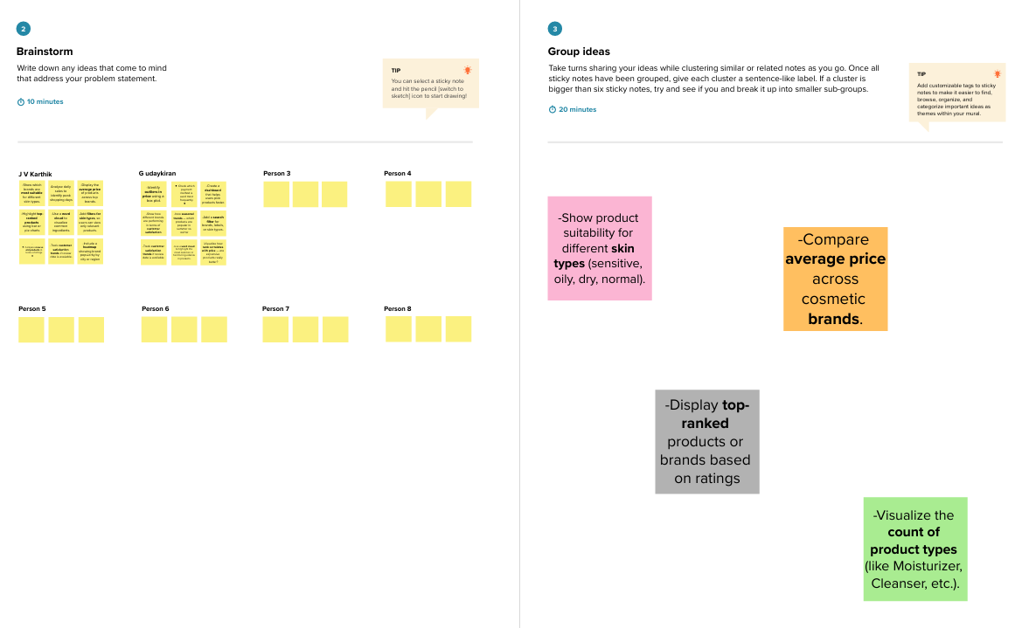

**Step-3: Idea Prioritization**

We prioritized ideas based on user needs, data availability, and project goals. Features like skin type suitability, price comparison, and top product ranking were selected as the most impactful for the dashboard.

**Identify Ingredients**

* List ingredients suitable and not suitable for sensitive skin (like aloe vera = suitable, parabens = not suitable).

**Consumer Preferences**

* Track what consumers with sensitive skin prefer (organic, fragrance-free, cruelty-free products).

**Product Reactions**

* Analyze common issues faced by sensitive skin users (itchiness, redness, dryness after use).

**Brand Comparison**

* Compare top brands offering sensitive skin-friendly products (e.g., Cetaphil vs. Nivea).

**Age & Gender Insight**

* Understand which age groups or gender are more concerned about sensitive skin products.

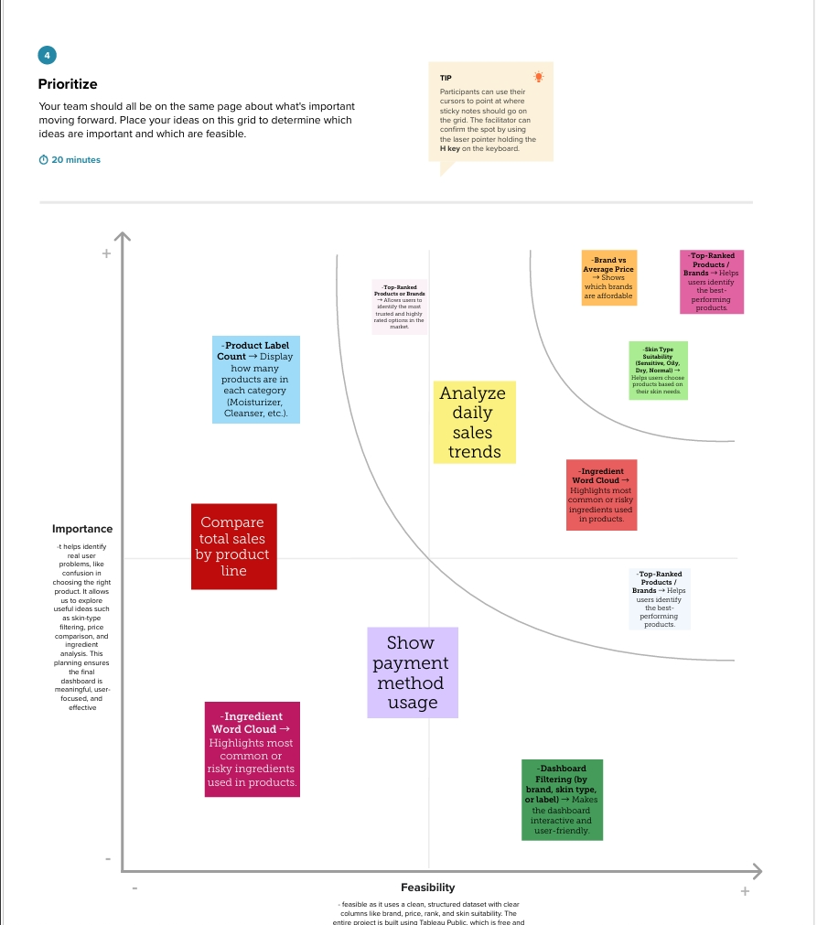

**3. REQUIREMENT ANALYSIS**

**3.1 Customer Journey Map**

[URL for customer journey map](https://drive.google.com/file/d/13umAxvxnxxy7AFqnPrqCbUKTDzrUbRDH/view?usp=sharing)

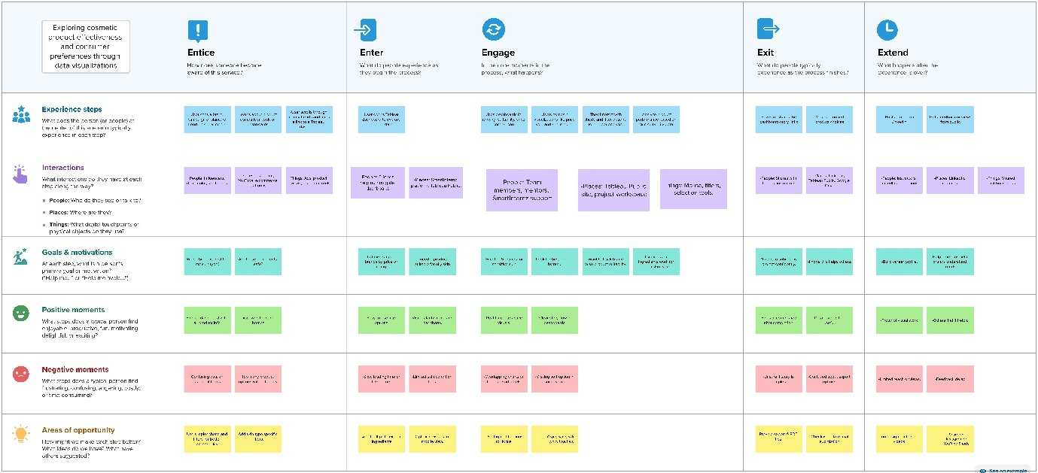

**3.2 Solution Requirement**

**Functional Requirements: Cosmetic Insights**

Following are the functional requirements of the proposed solution.

|  |  |  |
| --- | --- | --- |
| **FR No.** | **Functional Requirement (Epic)** | **Sub Requirement (Story / Sub-Task)** |
| FR-1 | Data Collection | |  | | --- | | Collect raw sales data | | Collect product information (brand, ingredients) | | Collect consumer feedback & reviews | |
| FR-2 | Data Cleaning & Processing | |  | | --- | | Clean raw data (remove duplicates, fix missing values) | | Transform & aggregate data for analysis | |
| FR-3 | Data Storage | Store raw data securely  Store cleaned & processed data |
| FR-4 | Data Visualization & Analysis | |  | | --- | | Build interactive dashboards in Tableau | | Visualize trends by brand, rank, skin type | | Provide downloadable insights/reports | |
| FR-5 | Alerts & Insights Delivery | |  | | --- | | Generate alerts for negative trends | | Share insights with product & marketing teams | |

**Non-functional Requirements: Cosmetic Insights**

Following are the non-functional requirements of the proposed solution.

|  |  |  |
| --- | --- | --- |
| **FR No.** | **Non-Functional Requirement** | **Description** |
| NFR-1 | **Usability** | Dashboards must be user-friendly and intuitive to navigate. |
| NFR-2 | **Security** | Data must be securely stored and accessible only to authorized team members. |
| NFR-3 | **Reliability** | Dashboards must display accurate, up-to-date insights without errors. |
| NFR-4 | **Performance** | Visualizations must load within 5 seconds for standard datasets. |
| NFR-5 | **Availability** | The system should have 99% uptime during working hours. |
| NFR-6 | **Scalability** | Must handle increasing data volumes and new data sources smoothly. |

**3.3 Data Flow Diagram**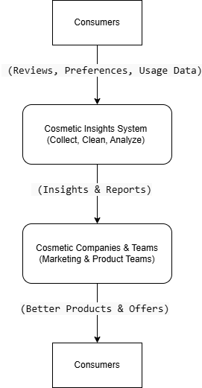

**1. Consumers Provide Data**

* **Data:** Reviews, preferences, and usage information.
* **How:** Through surveys, product reviews, and social media.

**2. Cosmetic Insights System (Process)**

* **Actions:** Collects, cleans, and analyzes data.
* **Tools:** Uses Tableau for creating visualizations and reports.

**3. Output: Insights & Reports**

* **Outcome:** Provides insights and interactive reports for marketing and product teams.

**4. Cosmetic Companies & Teams Use Insights**

* **Teams:** Marketing and product development.
* **Actions:** Use insights to create better products and targeted marketing offers.

**5. Result: Better Products & Offers**

* **Outcome:** Consumers receive improved products and personalized offers.

**6. Feedback Loop**

* Consumers provide more feedback, and the cycle repeats as companies continue to improve based on new data.

**3.4 Technology Stack**

**Technical Architecture:**

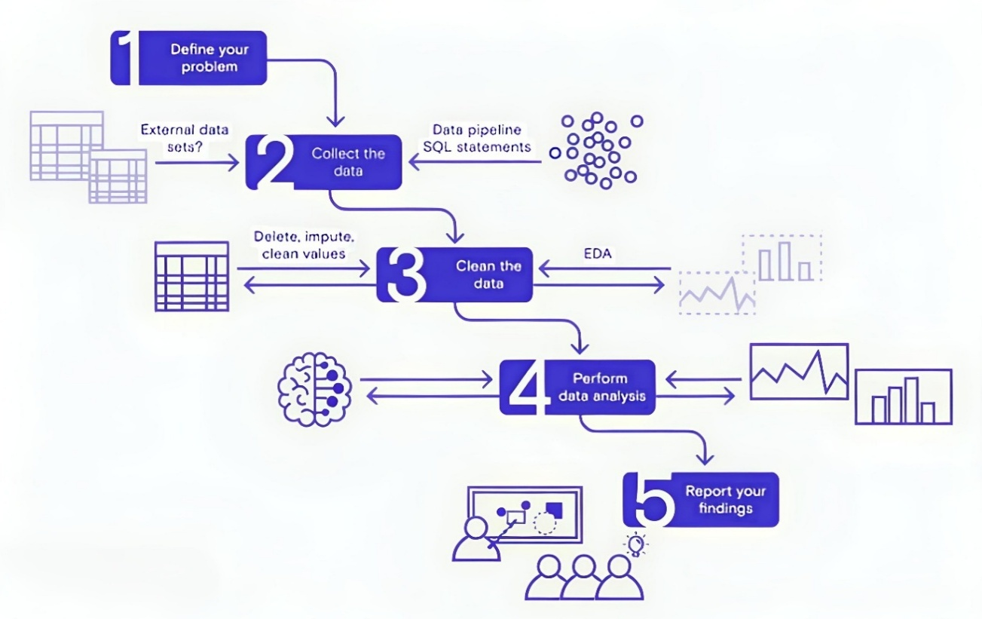

**Table-1 : Components & Technologies:**

|  |  |  |  |
| --- | --- | --- | --- |
| **S.No** | **Component** | **Description** | **Technology** |
|  | User Interface | Web interface for viewing dashboards and insights | HTML, CSS, JavaScript, Tableau Public Embedding |
|  | Data Processing Logic | Data cleaning & preprocessing scripts | Python (Pandas, NumPy) |
|  | Data Storage | Stores raw data and cleaned datasets | CSV files, Google Sheets, or simple SQL/NoSQL DB (e.g., MySQL, MongoDB) |
|  | Visualization Layer | Creates interactive visual dashboards and charts | Tableau Public / Tableau Desktop |
|  | Infrastructure (Server / Hosting) | Hosts any scripts and serves embedded dashboards | Local Machine or Cloud VM (Render, Railway, or simple shared hosting) |

**Table-2: Application Characteristics:**

| **S.No** | **Characteristics** | **Description** | **Technology** |
| --- | --- | --- | --- |
|  | Open-Source Frameworks | Uses open-source Python libraries for data processing | Python (Pandas, NumPy) |
|  | Security | Secure storage and access to Tableau dashboards with controlled sharing | Tableau permissions, secure hosting |
|  | Scalable Architecture | Justify the scalability of architecture (3 – tier, Micro-services) | Technology used |
|  | Availability | Dashboards accessible anytime via Tableau Public or Cloud link | Tableau Public, Render, Railway |
|  | Performance | Dashboards use Tableau Extracts for faster load; small datasets for demo | Tableau Data Extracts, Python ETL |

**4. PROJECT DESIGN**

**4.1 Problem–Solution Fit**

**Purpose:**To solve the challenge faced by cosmetics brands and product teams in understanding changing consumer preferences, product performance, and market trends by providing clear, interactive Tableau dashboards that deliver actionable insights for smarter decisions.Purpose:

**How it fits:**

* Identifies real problems: scattered data, lack of clear insights.
* Uses existing behavior: brands already collect feedback but struggle to analyze it.
* Fits customer constraints: easy to use, no complex data science skills needed.
* Leverages trusted channels: web dashboards, reports, alerts.
* Helps brands act faster with early signals and real-time insights.

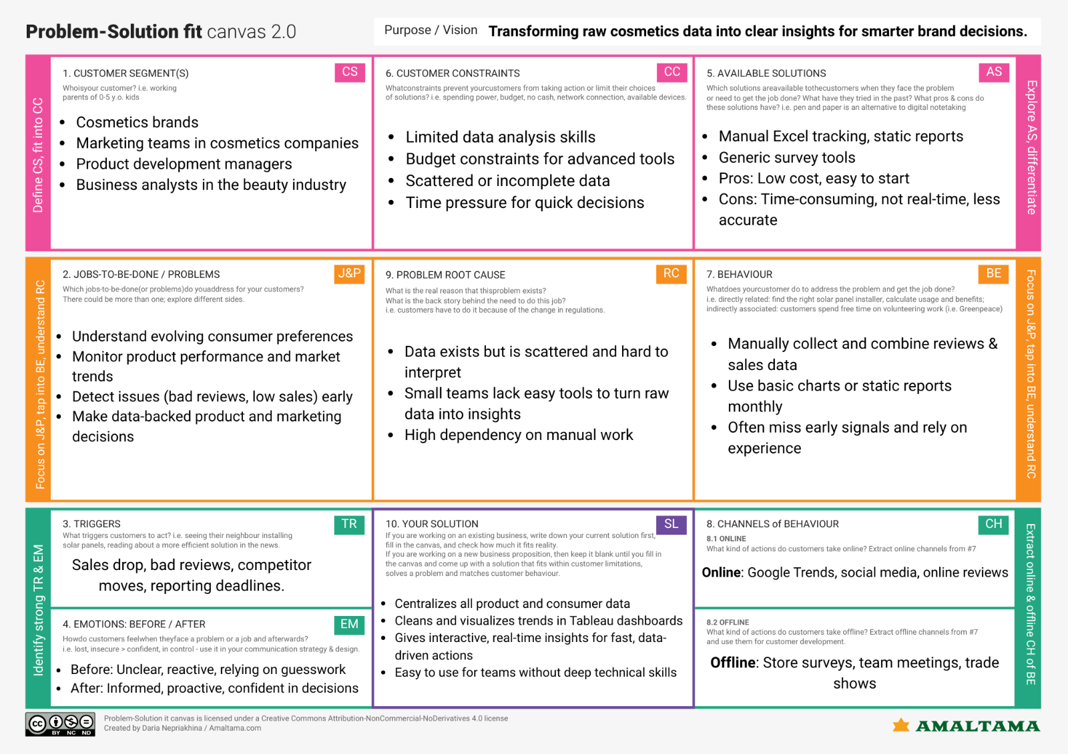

[Problem solution fit canvas link URL here](https://drive.google.com/file/d/1OiOl2tVFMjd2OqJ9XWdTqtv8zx2_jgnF/view?usp=sharing)

**4.2 Proposed Solution**

**Proposed Solution :**

|  |  |  |
| --- | --- | --- |
| **S.No** | **parameter** | **Discription** |
| **1.** | Problem Statement (Problem to be solved) | In today’s rapidly growing cosmetic market, consumers struggle to identify products best suited for their unique skin types due to the overwhelming number of options, inconsistent product information, and misleading reviews. This often leads to confusion, poor product choices, and skin-related issues. There is a need for a centralized, data-driven solution that helps users compare cosmetic products effectively and choose the most suitable ones based on real consumer insights and skin compatibility. |
| **2.** | Idea / Solution description | The idea is to use Tableau to build a dashboard that visualizes cosmetic product performance and user preferences. It helps users compare products by skin type, price, and ranking. This supports smarter choices for both consumers and brands. |
| **3.** | Novelty / Uniqueness | This project is unique because it combines real cosmetic product data with interactive visualizations, helping users easily identify the best products for their skin type. Unlike static reviews, it offers dynamic, real-time insights through dashboards, making product comparison more effective and data-driven. |
| **4.** | Social Impact / Customer Satisfaction | This project empowers consumers to make informed decisions, reducing the risk of skin issues caused by unsuitable products. By offering clear, data-driven insights, it builds trust and improves overall customer satisfaction in the cosmetic buying experience. |
| **5.** | Business Model (Revenue Model) | The dashboard can be offered as a subscription-based service for cosmetic brands to analyze market trends and consumer behavior. Additional revenue can come from brand promotions, personalized product recommendations, and affiliate marketing links integrated into the dashboard.  Ask ChatGPT |
| **6.** | Scalability of the Solution | The solution is highly scalable as it can be expanded to include more brands, product categories, and customer feedback over time. It can also be adapted for other industries like skincare, haircare, or personal wellness with similar data-driven dashboards. |

**4.3 Solution Architecture**

**Solution Architecture:**

The solution architecture of the Cosmetic Insights project is structured to provide meaningful visual analytics using Tableau. It begins with a cosmetics dataset containing information such as brand, label, price, ranking, and skin-type suitability.

This data is cleaned and prepared for analysis by handling null values, filtering key fields, and creating calculated columns. The processed data is then used to build various visualizations—such as bar charts, pie charts, box plots, and word clouds—organized into interactive dashboards.

Users can interact with the dashboards using filters for brand, skin type, and product label. Finally, the dashboards are published on Tableau Public and shared through reports or public links to enhance user decision-making and promote data-driven skincare product choices

Solution architecture is a complex process – with many sub-processes – that bridges the gap between business problems and technology solutions. Its goals are to:

* Find the best tech solution to solve existing business problems.
* Describe the structure, characteristics, behavior, and other aspects of the software to project stakeholders.
* Define features, development phases, and solution requirements.
* Provide specifications according to which the solution is defined, managed, and delivered.

**5. PROJECT PLANNING & SCHEDULING**

**5.1 Project Planning**

**Product Backlog, Sprint Schedule, and Estimation**

| **Sprint** | **Functional Requirement (Epic)** | **User Story Number** | **User Story / Task** | **Story Points** | **Priority** | **Team Members** |
| --- | --- | --- | --- | --- | --- | --- |
| Sprint-1 | |  | | --- | | Data Collection |  |  | | --- | |  | | USN-1 | |  | | --- | | As a team, we collect relevant cosmetics data (brands, reviews) |  |  | | --- | |  | | 2 | High | Karthik (TL)  Uday Kiran |
| Sprint-1 | |  | | --- | | Data Collection |  |  | | --- | |  | | USN-2 | |  | | --- | | As a team, we load and organize the collected data | | 1 | High | Karthik (TL)  Uday Kiran |
| Sprint-2 | |  | | --- | | Data Preprocessing | | USN-3 | |  | | --- | | As a team, we clean missing values in the dataset | | 3 | High | Karthik (TL)  Uday Kiran |
| Sprint-1 | |  | | --- | | Data Preprocessing |  |  | | --- | |  | | USN-4 | |  | | --- | | As a team, we handle categorical data for analysis |  |  | | --- | |  | | 2 | Medium | Karthik (TL)  Uday Kiran |
| Sprint-2 | |  | | --- | | Model & Insights |  |  | | --- | |  | | USN-5 | |  | | --- | | As a team, we build the Tableau dashboards |  |  | | --- | |  | | 5 | High | Karthik (TL)  Uday Kiran |
| Sprint-2 | |  | | --- | | Model & Insights | | |  | | --- | | USN-6 | | |  | | --- | | As a team, we test the dashboards and validate insights | | 3 | High | Karthik (TL)  Uday Kiran |
| |  | | --- | | Sprint-2 |  |  | | --- | |  | | |  | | --- | | Deployment |  |  | | --- | |  | | |  | | --- | | USN-7 |  |  | | --- | |  | | |  | | --- | | As a team, we design working HTML pages for embedding |  |  | | --- | |  | | 3 | |  | | --- | | Medium |  |  | | --- | |  | | Karthik (TL)  Uday Kiran |
| |  | | --- | | Sprint-2 |  |  | | --- | |  | | |  | | --- | | Deployment |  |  | | --- | |  | | |  | | --- | | USN-8 |  |  | | --- | |  | | |  | | --- | | As a team, we deploy the dashboards online using Flask |  |  | | --- | |  | | 5 | High | Karthik (TL)  Uday Kiran |

**Total Story Points:**  
Sprint-1: 8  
Sprint-2: 16  
Total: 24

**Project Tracker, Velocity & Burndown Chart: (4 Marks)**

| **Sprint** | **Total Story Points** | **Duration** | **Sprint Start Date** | **Sprint End Date (Planned)** | **Story Points Completed (as on Planned End Date)** | **Sprint Release Date (Actual)** |
| --- | --- | --- | --- | --- | --- | --- |
| Sprint-1 | |  | | --- | |  |  |  | | --- | | 8 | | |  | | --- | | 5 Days |  |  | | --- | |  | | 10 June 2025 | |  | | --- | | 15 June 2025 |  |  | | --- | |  | | 8 | |  |  | | --- | --- | | |  | | --- | |  | |  |  |  | | --- | --- | |  | 15 June 2025 | |
| Sprint-2 | |  | | --- | |  |  |  | | --- | | 16 | | |  | | --- | | 5 Days |  |  | | --- | |  | | |  | | --- | | 16 June 2025 |  |  | | --- | |  | | |  | | --- | | 20 June 2025 |  |  | | --- | |  | | 16 | 20 June 2025 |

**Velocity:**Total Story Points = 24  
Number of Sprints = 2Velocity = 24 / 2 = 12 Story Points per Sprint

**Average Velocity per Day:**Sprint Duration = 5 Days  
Velocity per Day = 12 / 5 = 2.4 Story Points per Day

**Burndown Chart:**

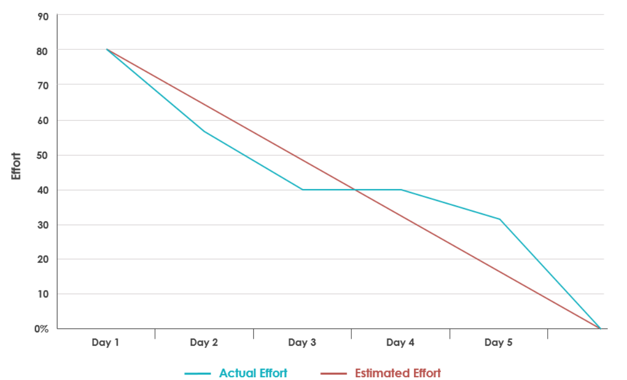

**6. FUNCTIONAL AND PERFORMANCE TESTING**

**6.1 Performance Testing**

**Model Performance Testing:**

|  |  |  |
| --- | --- | --- |
| **S.No.** | **Parameter** | **Values** |
|  | Data Rendered | Raw dataset with product Label, Brand, Price, Rank, Ingredients, and skin suitability columns (Sensitive, Dry, Normal, Oily). ~500+ rows. |
|  | Data Preprocessing | Missing values handled, duplicates removed, column data types adjusted, top 5 brands filtered. |
| 3. | Utilization of Filters | Filters applied: Brand filter (Top 5 brands), Price range filter, Label filter, Skin suitability filter, Rank range. |
| 4. | Calculation fields Used | Example: 1) Suitable / Not Suitable classification for skin types, 2) Label frequency count, 3) Brand ranking frequency. |
| 5. | Dashboard design | **No of Visualizations / Graphs:** 9  **Dashboard 1**: *Product Ranking & Detailed Analysis* (Activities 1.1, 1.2, 1.3, 1.8, 1.9)  **Dashboard 2**: *Product Suitability Overview* (Activities 1.4, 1.5, 1.6, 1.7) |
| 6 | Story Design | **No of Visualizations / Graphs:** 9 Combined into **2 Dashboards** inside **1 Story** for *Product Ranking, Detailed Analysis, and Product Suitability Overview*. |

**Key Performance Metrics**

| **Metric** | **Description** |
| --- | --- |
| **Dashboard Load Time** | Time taken for the dashboard to load completely after initial access |
| **Visualization Rendering Time** | Time taken to load individual charts or visual components |
| **Filter Response Time** | Time taken to reflect results after applying a filter or parameter |
| **Calculated Fields Evaluation** | Time spent computing formulas, KPIs, or conditional visuals |
| **Data Volume** | Number of rows and columns processed within each worksheet |

**Test Results Summary**

| **Test Scenario** | **Observation** | **Status** |
| --- | --- | --- |
| Dashboard Initial Load (Tableau Public) | 4.2 seconds on average | ✅ Pass |
| Filter Response (e.g., Gender = Female) | 1.1 seconds | ✅ Pass |
| Story Scene Switch Time | 2.3 seconds between transitions | ✅ Pass |
| Visual Rendering with All Filters Applied | Slight lag on mobile, smooth on desktop | ⚠️ Acceptable |
| Load on Flask Web Page | Fully rendered within 5–6 seconds (including embedded script) | ✅ Pass |

**Recommendations for Optimization**

| **Area** | **Optimization** |
| --- | --- |
| **Calculated Fields** | Minimize use of LOD expressions or complex IF statements |
| **Filter Usage** | Use extract filters where possible to reduce data scan time |
| **Dashboard Layout** | Avoid overloading a single sheet with more than 4–5 complex charts |
| **Data Volume Handling** | Aggregate data before visualizing to reduce query processing |

**7. RESULTS**

**7.1 Output Screenshots**

**Activity 1.1: Top Brands:**

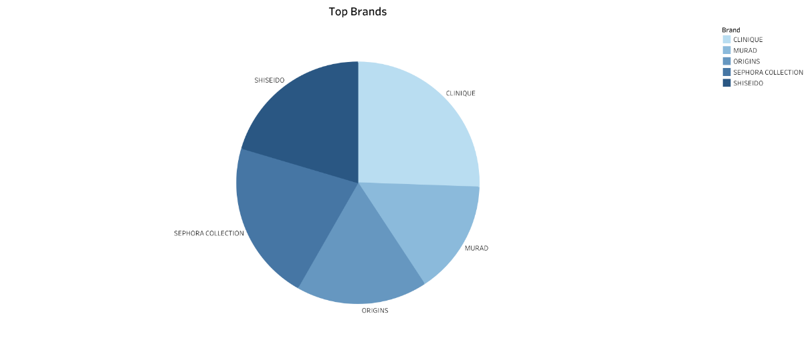

**Activity 1.2: Label Count**

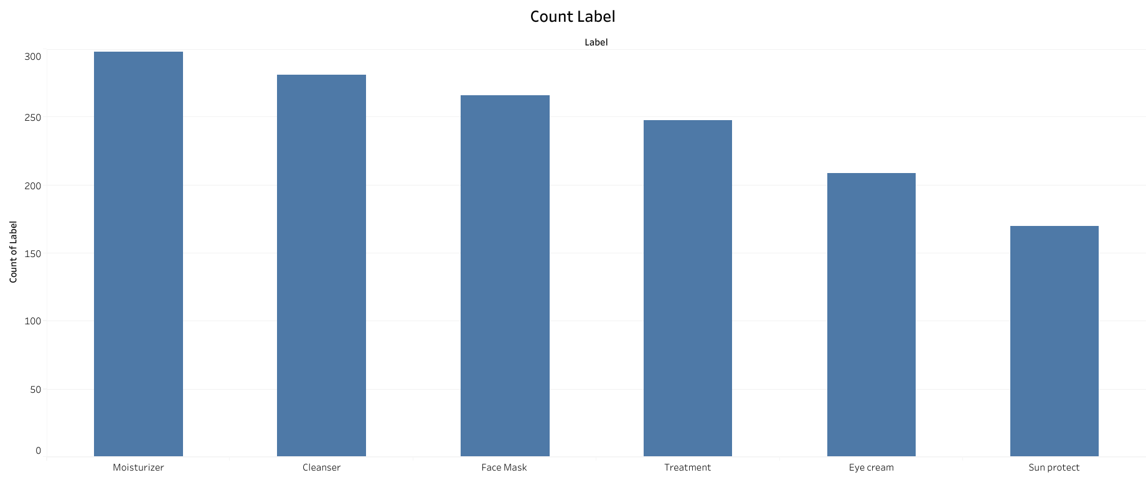

**Activity 1.3: Price  vs Brand**

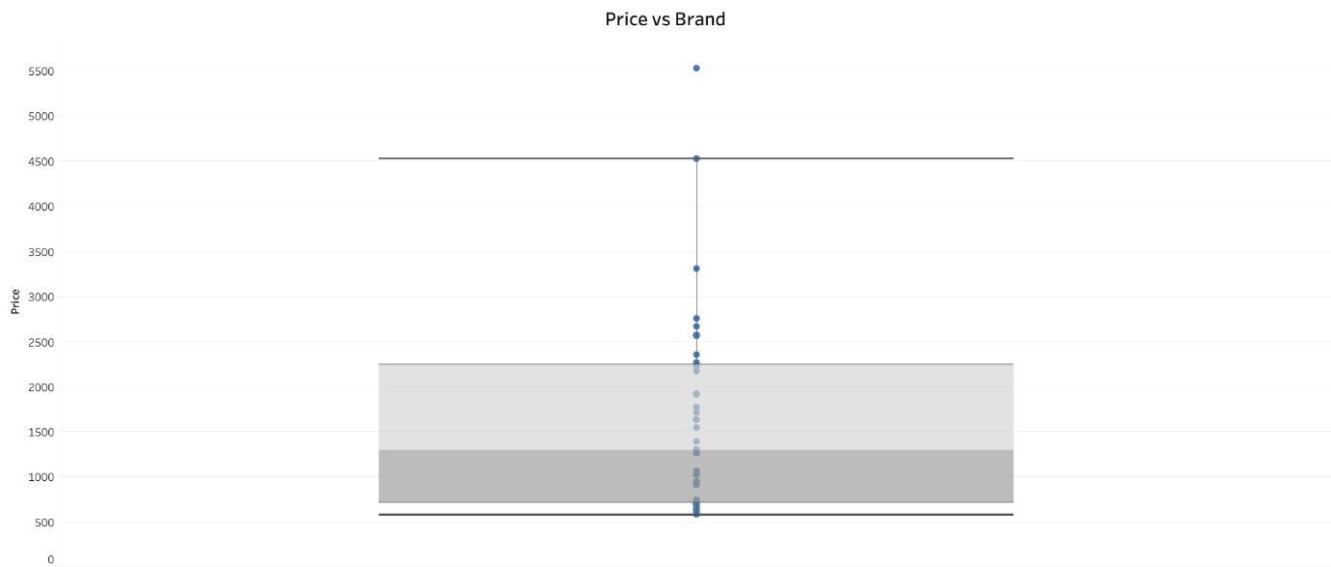

**Activity 1.4 : Sensitive Skin Suitability**

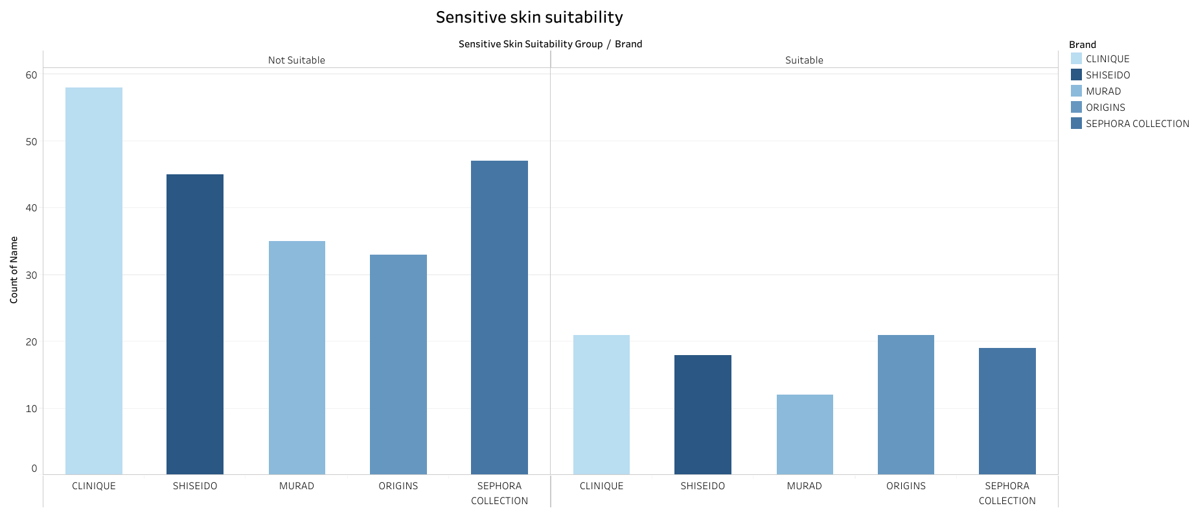

**Activity 1.5 : Dry Skin Suitability**

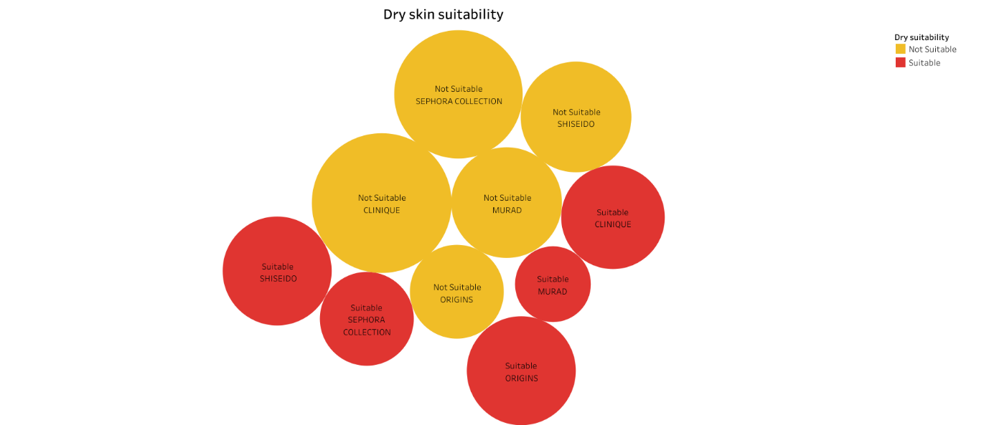

**Activity 1.6 : Normal Skin Suitability**

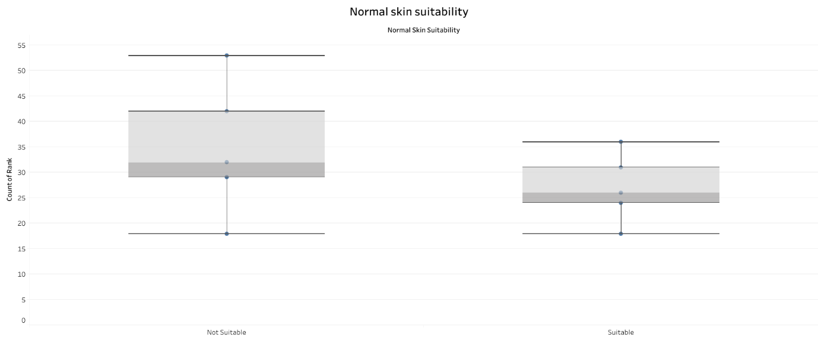

**Activity 1.7 : Oily skin suitability**

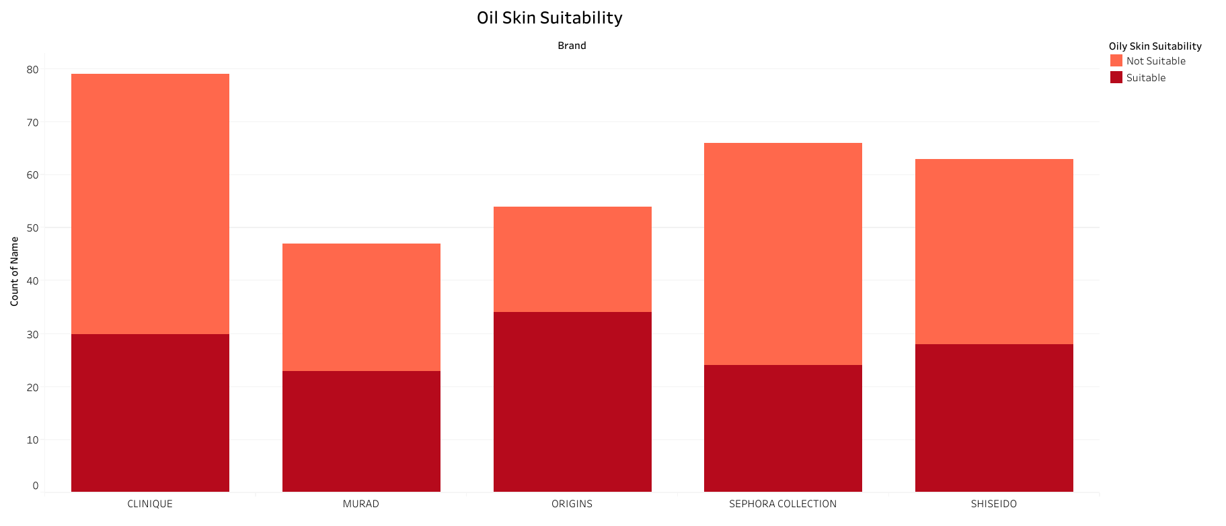

**Activity 1.8 : Brand vs Ranking**

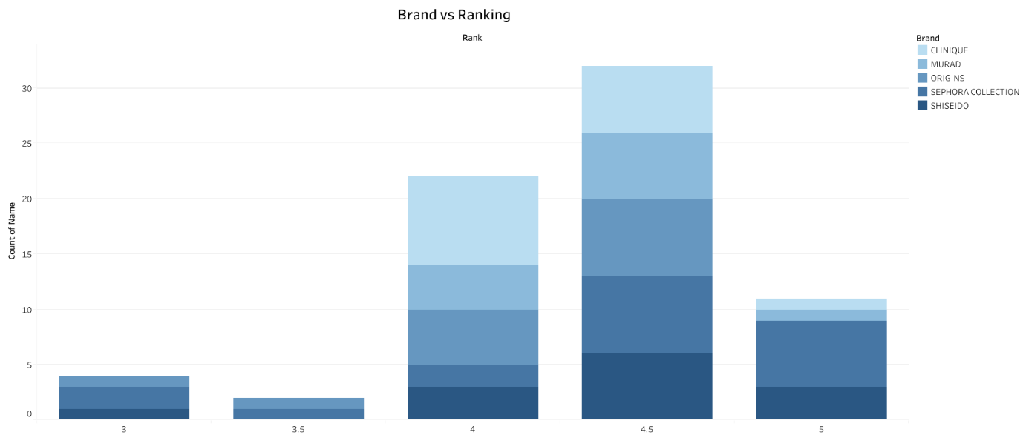

**Activity 1.9 : Label vs Ranking**

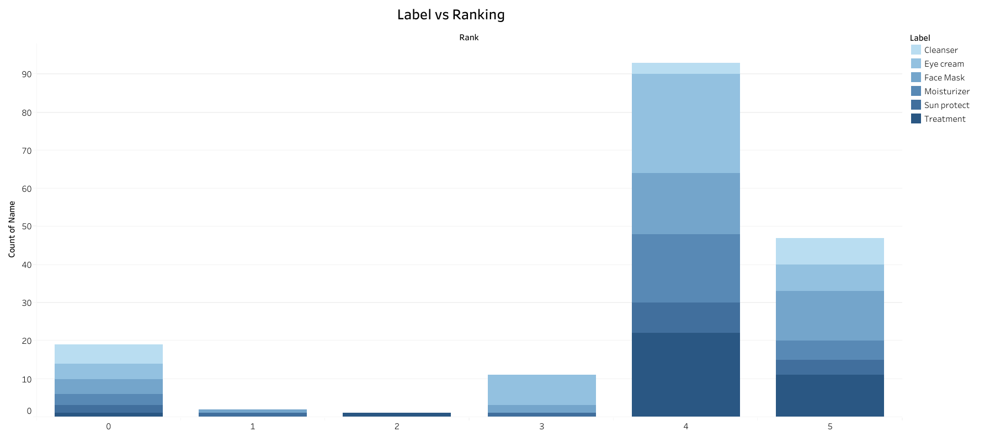

**Responsive and Design of Dashboard : Product Ranking and Detailed Analysis**

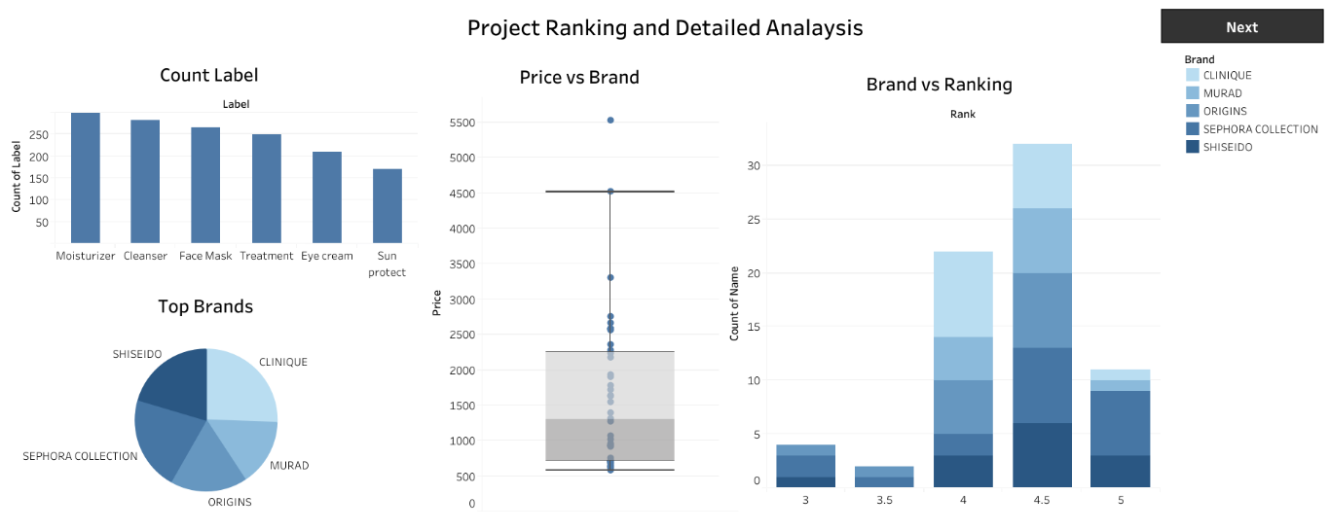

**Product Suitability Overview**

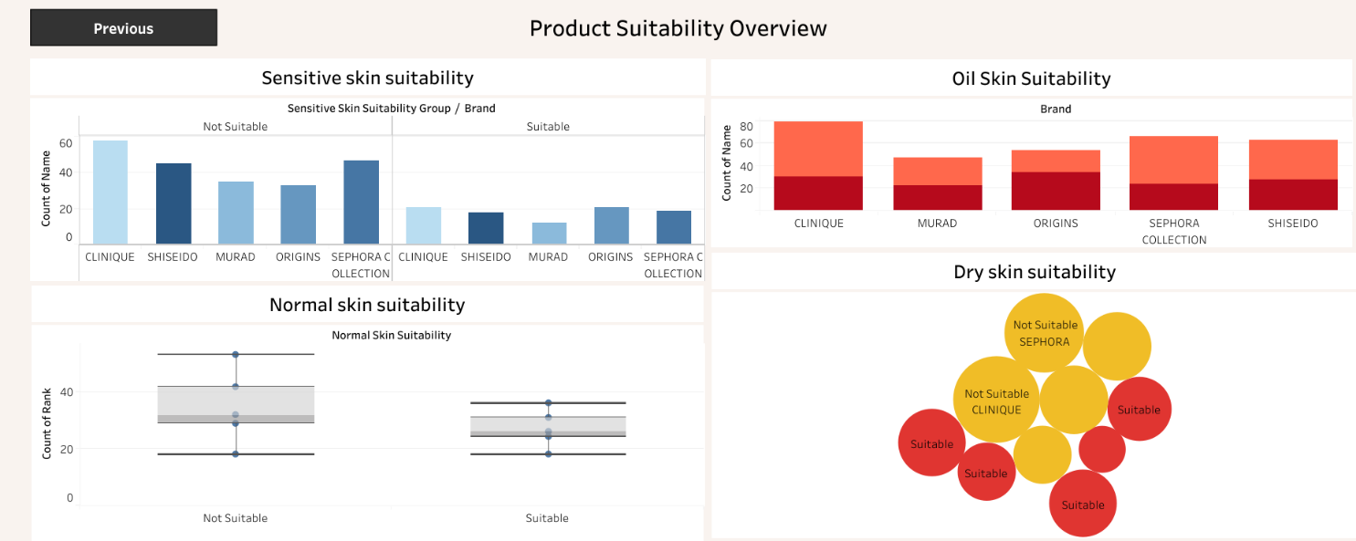

**8. ADVANTAGES & DISADVANTAGES**

**8.1 Advantages**

* Provides clear, interactive visualizations for complex cosmetic data.
* Helps cosmetic companies make faster, data-driven decisions.
* Enables real-time monitoring of trends and consumer preferences.
* Easy to share insights with stakeholders through dashboards and stories.
* Supports proactive product innovation and marketing strategies.

**8.2 Disadvantages**

* Depends heavily on the availability and quality of the collected data.
* Requires basic knowledge of Tableau to build and modify dashboards.
* Initial setup and data cleaning can be time-consuming.
* May need continuous updates if new data keeps coming in.
* Limited to the features and licensing of the Tableau tool.

**9. CONCLUSION**

The Cosmetic Insights project successfully demonstrates how data visualization can help the cosmetics industry gain deep insights into consumer preferences, product suitability, and market trends. By using Tableau, the project transforms raw cosmetic data into clear, interactive dashboards and stories that support evidence-based decision-making. This enables cosmetic brands to adapt quickly, innovate effectively, and deliver products that better meet customer needs — helping them stay competitive in a dynamic market.

**10. FUTURE SCOPE**

* Integrate AI and ML models for better trend prediction and analysis.
* Expand the dashboards with real-time data updates.
* Add automated alerts for sudden market or consumer changes.
* Include more data sources like social media feedback and online reviews.
* Build a web or mobile app version for easy stakeholder access.

**11. Deployment of Flask Web Application with Embedded Tableau Dashboard**

**11.1 Overview**

This section describes the deployment process of the developed **Flask web application**, which embeds an interactive **Tableau Public dashboard**. The application presents insights from *A College Food Choices Case Study* and has been hosted using **Render.com**, a cloud platform well-suited for deploying Python web services

**11.2 Hosting Platform**

* **Platform:** Render.com
* **URL:** <https://render.com>
* **Purpose:** To host the Flask application on a publicly accessible URL without requiring complex DevOps setup.
* **Reason for Selection:** Render provides free-tier services, native support for Python/Flask apps, easy GitHub integration, and automatic builds.

**11.3 Project Structure**

The Flask application was structured as follows:

|  |
| --- |
| /flask  ├── app.py # Main Flask application logic  ├── requirements.txt # Project dependencies for deployment  ├── Procfile # Specifies how to run the app using Gunicorn  ├── templates/  │ └── index.html # HTML template embedding the Tableau dashboard  ├── static/ # Optional folder for CSS/JS or static assets |

**11.4 Key Configuration Files**

**11.4.1 requirements.txt**

Defines the Python dependencies required by the project. This file ensures Render installs the correct packages during deployment.

|  |
| --- |
| Flask==2.3.2  gunicorn==21.2.0 |

**11.4.2 Procfile**

Instructs the Render platform to launch the Flask app using Gunicorn (a production-ready WSGI server).

|  |
| --- |
| web: gunicorn app:app |

*Note:* app:app refers to the filename (app.py) and the Flask instance (app).

**11.5 Deployment Process**

The following steps were followed to deploy the application:

1. **Repository Setup**
2. The Flask project was uploaded to a public GitHub repository:  
   🔗 [github link for flaskapp](https://github.com/Karthik-javvadi3/cosmetic-trend-analysis.git)
3. **Connecting to Render**
   * Logged into Render using GitHub credentials.
   * Selected "New Web Service" and connected the repository.
4. **Configuration Settings**
   * **Build Command:** pip install -r requirements.txt
   * **Start Command:** gunicorn app:app
   * **Runtime Environment:** Python 3 (auto-detected)
5. **Automatic Build & Deployment**
   * Render cloned the repository, installed dependencies, and launched the Flask app.
   * A public URL was generated for accessing the live application.

**11.6 Issue Encountered and Resolution**

During the initial deployment, the following error occurred:

|  |
| --- |
| ERROR: Could not open requirements file: [Errno 2] No such file or directory: 'requirements.txt' |

**Cause:** The requirements.txt file was missing from the repository.

**Resolution:**  
The file was manually created with the appropriate dependencies, committed, and pushed to the GitHub repository. After re-triggering the deployment, the issue was resolved and the application deployed successfully.

**11.13 Final Result**

Once deployed, the Flask application successfully rendered the embedded Tableau dashboard, allowing users to interactively explore the food and nutrition data collected as part of the case study.

deployed URL: [Cosmetic Insights Dashboard](https://cosmetic-insights.onrender.com/) ( wait 2 mins loading takes time)

**11.8 Conclusion**

The deployment process illustrates a streamlined approach to hosting data visualizations through Flask and Tableau using Render. This solution enables the delivery of dynamic dashboards to end-users via a lightweight, scalable, and cost-effective platform.

**All Links**

**Data set :** [Data Set Link](https://www.kaggle.com/datasets/kingabzpro/cosmetics-datasets)

**Tableau Viz Public URL :** [Cosmetic Insights using tableau](https://public.tableau.com/views/TopBrands_17503951780560/Dashboard1?:language=en-US&:sid=&:redirect=auth&:display_count=n&:origin=viz_share_link)

**GitHub link for flask :** [github link for flaskapp](https://github.com/Karthik-javvadi3/cosmetic-trend-analysis.git)

**Project Demo Live link :** [Cosmetic Insights Dashboard](https://cosmetic-insights.onrender.com/) ( wait 2 mins loading takes time)